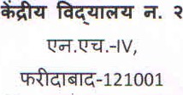  a- 2415656, 2432485  - kv2faridabad@gmail.com  -www.n02faridabad.kvs.ac.in |  |  |  | KENDRIYA VIDYALAYA No-2  N.H.-IV  Faridabad — 121001 a-2415656, 2432485  E.Mail kv2faridabad@gmaiI.com Website www.n02faridabad.kvs.ac.in
F. W-2 FARIDABAD/2021-22 | 92- |  | Date: 10.02.2022

